**Setup and Initialization**

Install the required firebase packages:

npm install @angular/fire firebase –save

npm install angularfire2

npm install -g firebase-tools

npm install rxjs-compat (To let map operator work)

**Connect Database with Project**

src/environments/environment/environment.ts

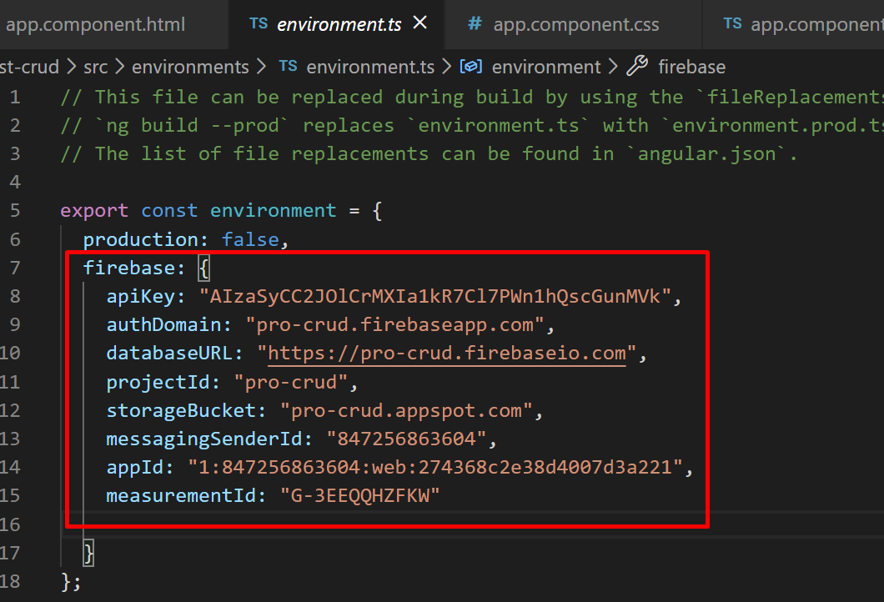

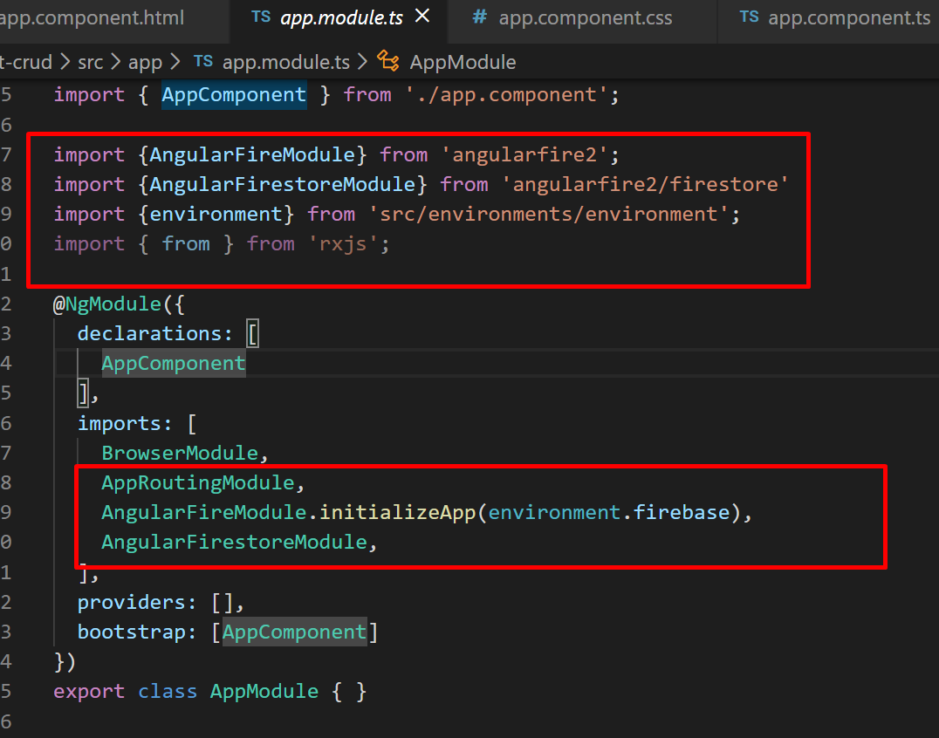

**Database in Firebase:**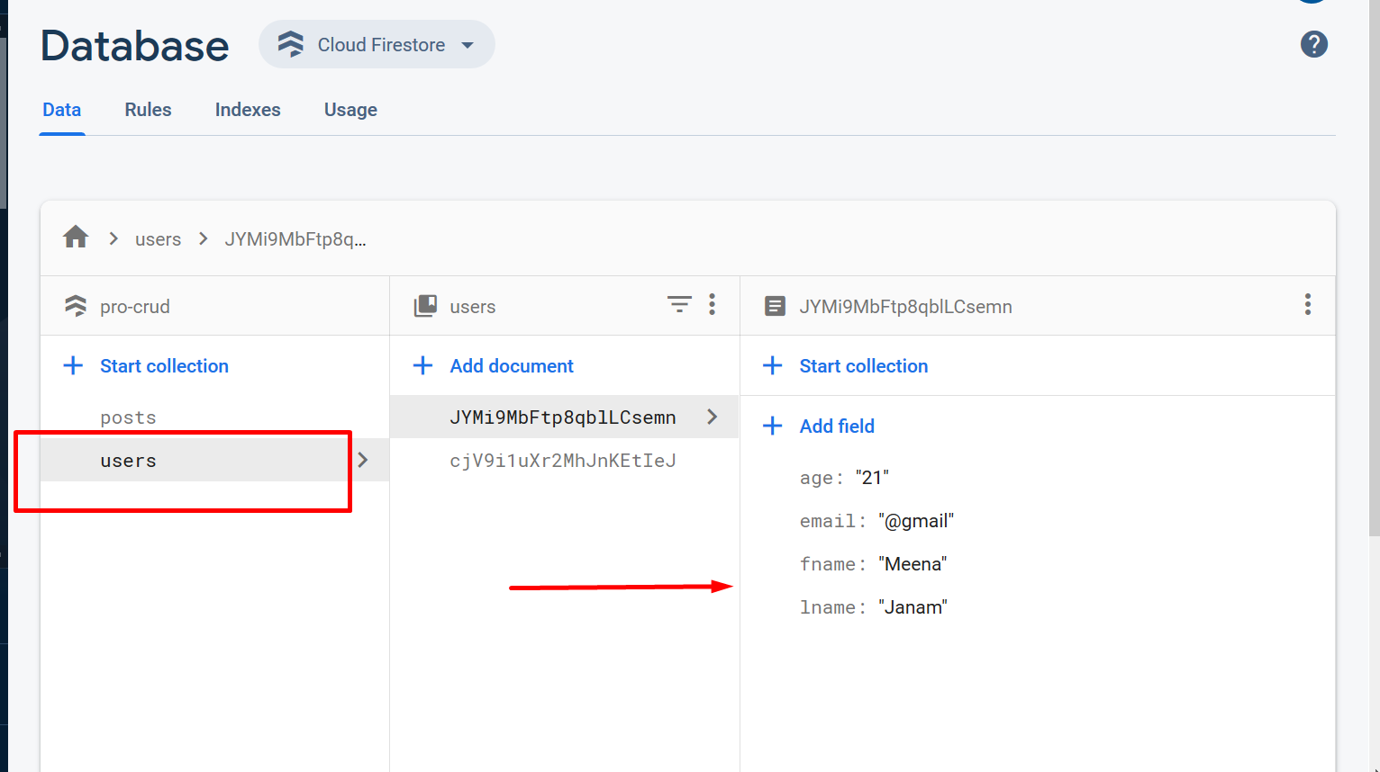

**Configure Route:**

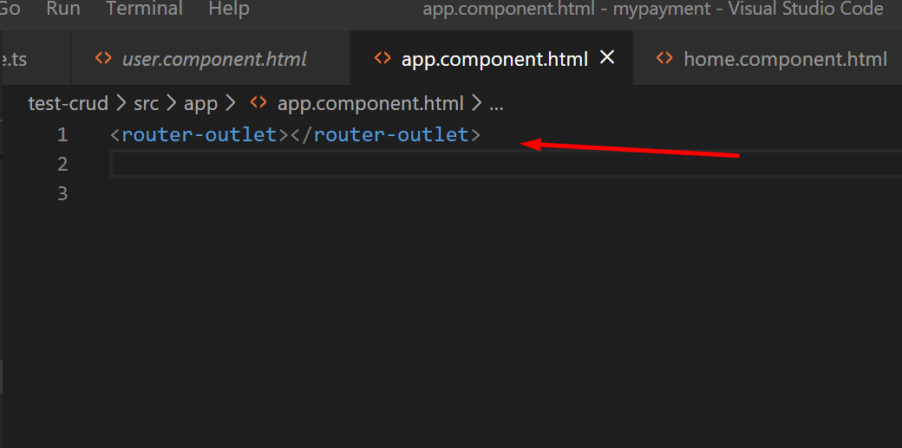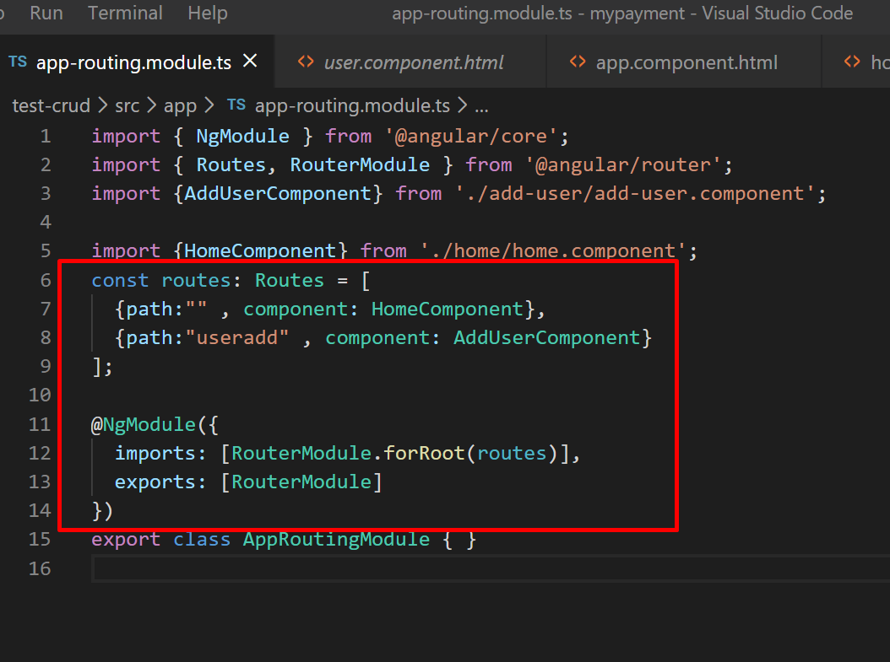

**Performing Read Operation from Database: C RUD**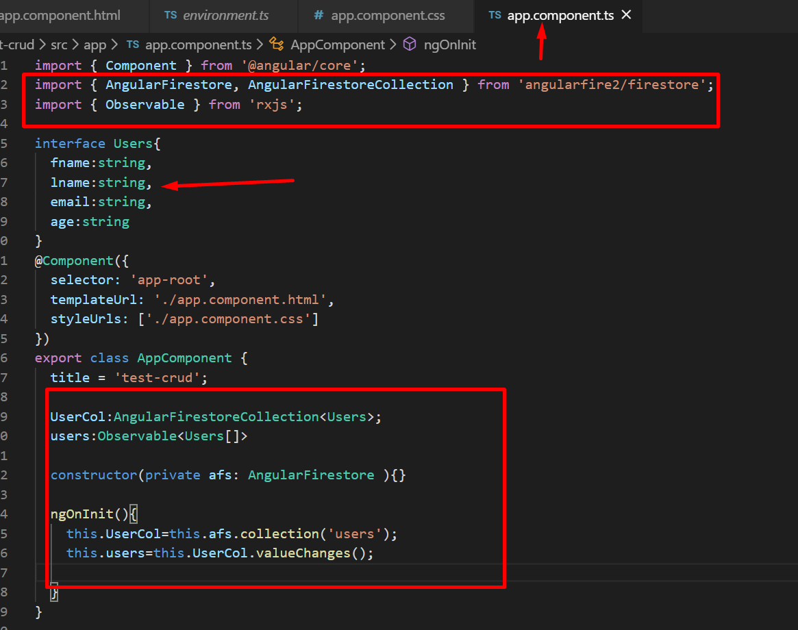

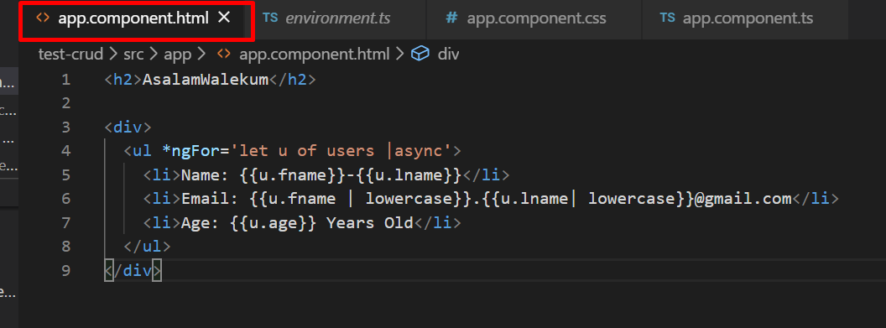

**Performing Create Operation: C RUD**

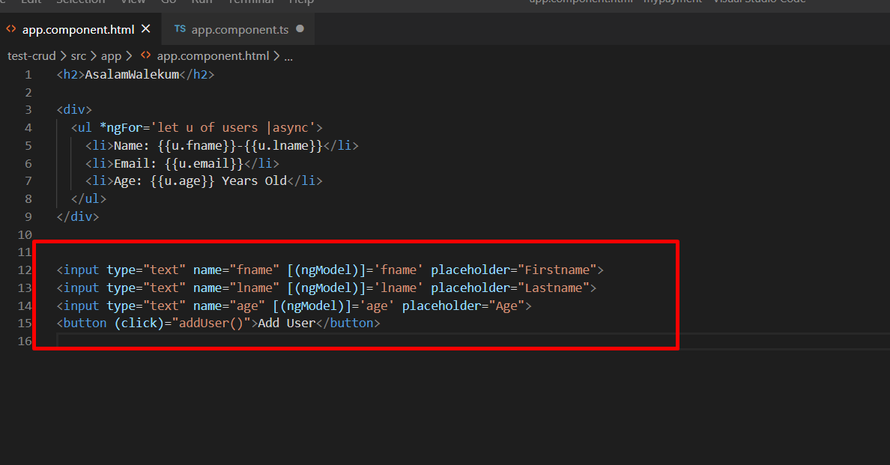

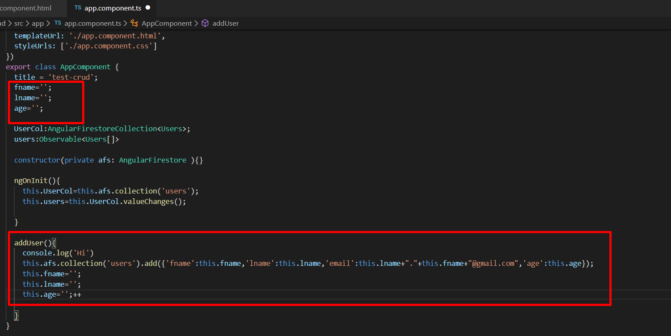

**Performing Update Operation from Database: CRUD**

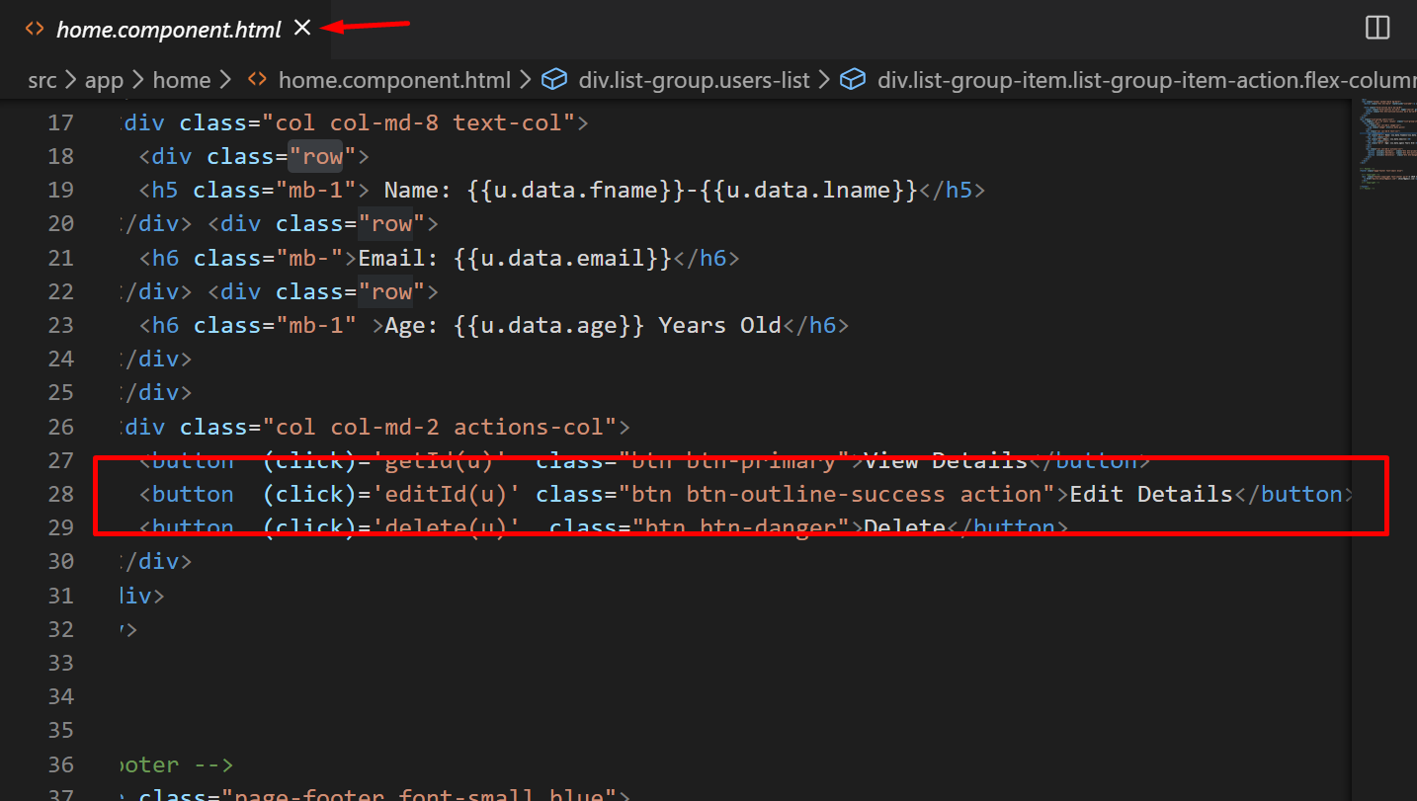

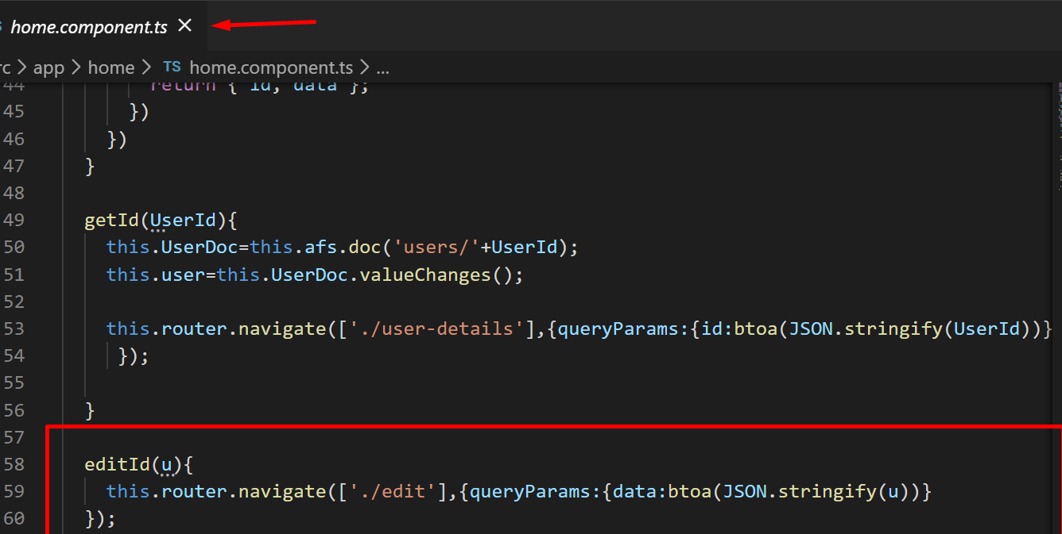

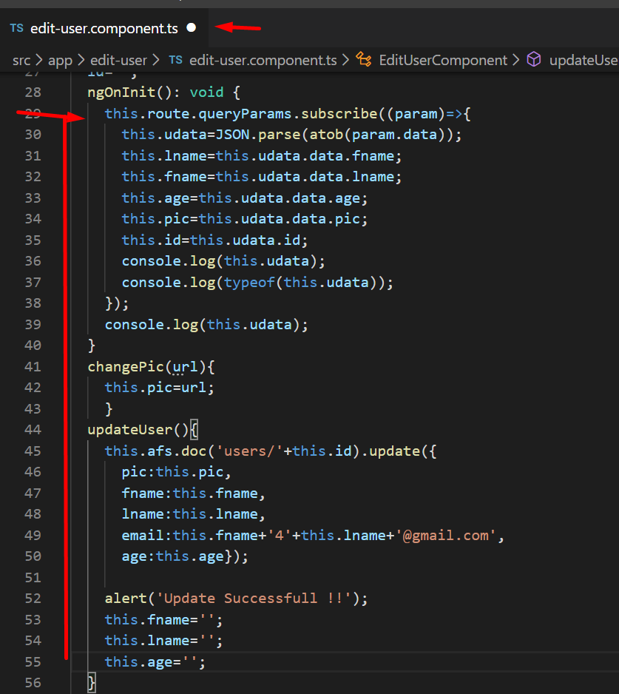

**Performing Delete Operation from Database: CRUD**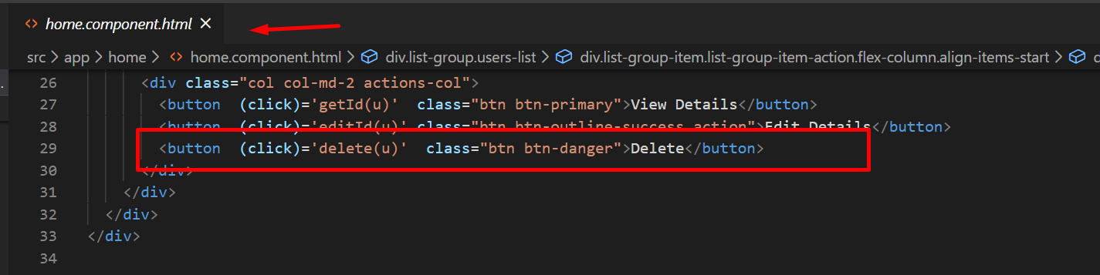

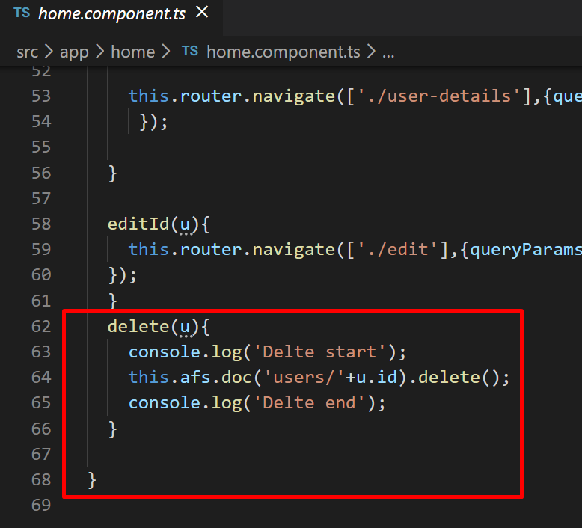

**Firebase Initialization and deployment**

Install the required bootstrap packages for CSS to make its look good:

npm install --save bootstrap

@import "~bootstrap/dist/css/bootstrap.css" (in the global style.css file)

**npm i -g firebase-tools**

Google fire base cli. **firebase login** **firebase list (to select project)**

**firebase init**

**Note:** change the path for project to **dist/name_of_your_project**

Build the project with **ng build –prod**

**firebase deploy**

**Gr8 it’s Done ;)**